# React

# 3.ReactJS-HOL

# Mandatory HandsOn

**Create a react app for Student Management Portal named scorecalculatorapp and create a function component named “CalculateScore” which will accept Name, School, Total and goal in order to calculate the average score of a student and display the same**

1.Create a React project named “scorecalculatorapp” type the following command in terminal of Visual studio:



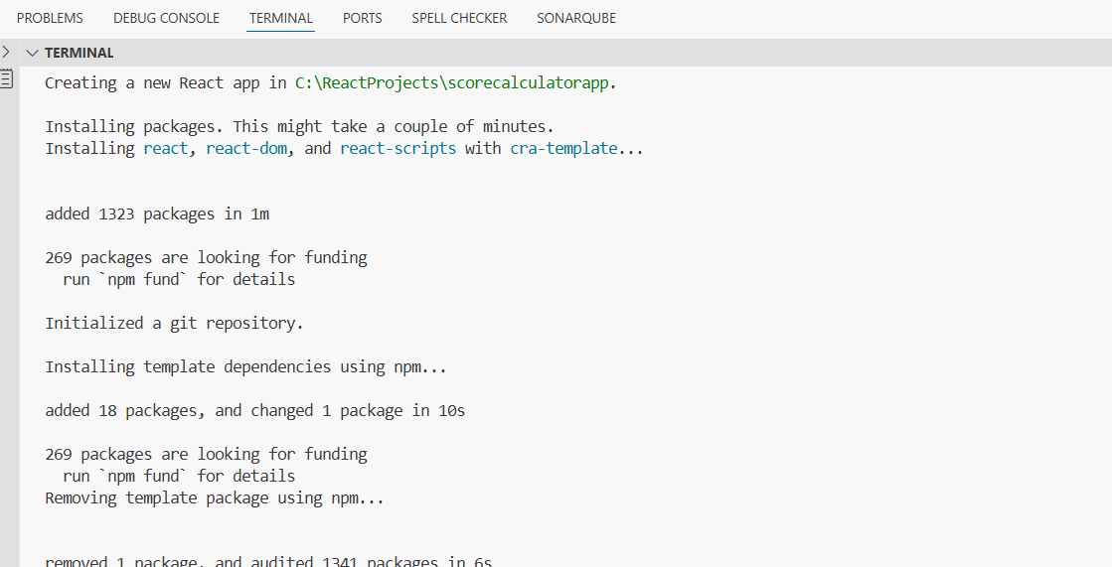

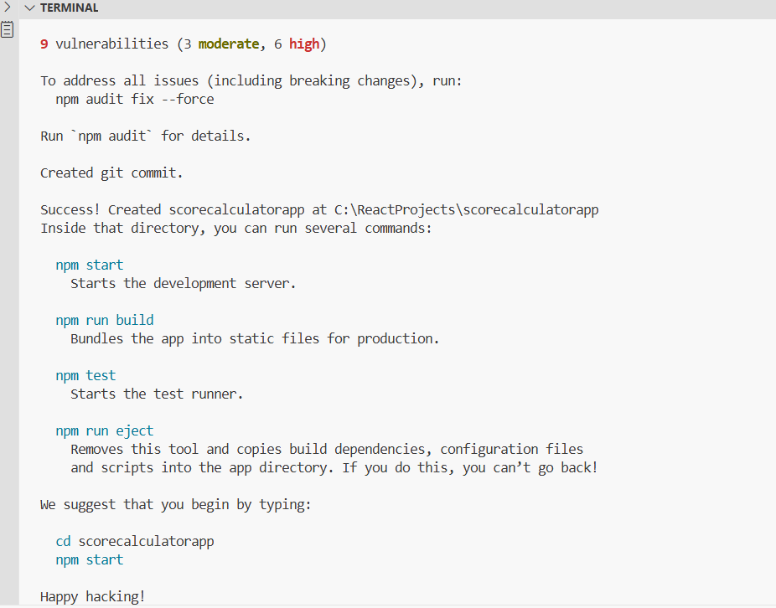

2.Create a new folder under Src folder with the name “Components”. Add a new file named “CalculateScore.js”

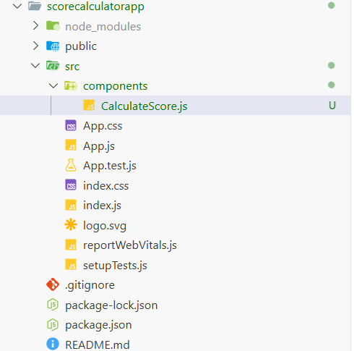

3.Type the following code in CalculateScore.js

**//src/components/CalculateScore.js**

import '../Stylesheets/mystyle.css';

const percentToDecimal = (decimal) => {

return (decimal.toFixed(2) + '%');

};

const calcScore = (total, goal) => {

return percentToDecimal(total / goal);

};

export const CalculateScore = ({ Name, School, total, goal }) => (

<div className="formatstyle">

<h1><font color="Brown">Student Details:</font></h1>

<div className="Name">

<b><span> Name: </span></b>

<span>{Name}</span>

</div>

<div className="School">

<b><span> School: </span></b>

<span>{School}</span>

</div>

<div className="Total">

<b><span>Total: </span></b>

<span>{total}</span>

<span>Marks</span>

</div>

<div className="Score">

<b>Score:</b>

<span>{calcScore(total, goal)}</span>

</div>

</div>

);

4.Create a Folder named Stylesheets and add a file named “mystyle.css” in order to add some styles to the components:

**//src/Stylesheets/mystyle.css**

import '../Stylesheets/mystyle.css';

const percentToDecimal = (decimal) => {

return (decimal.toFixed(2) + '%');

};

const calcScore = (total, goal) => {

return percentToDecimal(total / goal);

};

export const CalculateScore = ({ Name, School, total, goal }) => (

<div className="formatstyle">

<h1><font color="Brown">Student Details:</font></h1>

<div className="Name">

<b><span> Name: </span></b>

<span>{Name}</span>

</div>

<div className="School">

<b><span> School: </span></b>

<span>{School}</span>

</div>

<div className="Total">

<b><span>Total:</span></b>

<span>{total}</span>

<span> Marks</span>

</div>

<div className="Score">

<b>Score:</b>

<span>{calcScore(total, goal)}</span>

</div>

</div>

);

5.Edit the App.js to invoke the CalculateScore functional component as follows:

**App.js**

import { CalculateScore } from './components/CalculateScore';

function App() {

return (

<div>

<CalculateScore

Name="Steeve"

School="DNV Public School"

total={284}

goal={3}

/>

</div>

);

}

export default App;

6.In command Prompt, navigate into scorecalculatorapp and execute the code by typing the following command:

cd scorecalculatorapp



7.Open browser and type “localhost:3000” in the address bar:

<http://localhost:3000/>

